Build is CI and Release is used for CD/Continues Deployment.

Build a CI/CD pipeline DevOps: <https://www.youtube.com/watch?v=yNESSInONyk>

We need version control like git, to push code to some branch/master and from our branch setup build.

We can select existing templates which are collections of task for different type of projects including Azure Service Fabric Apps, Azure web apps, Azure Cloud Services, .net core, Asp.Net with Containers,

You can also go to Pipelines and Builds to add new/edit existing build.

Builds usually publish Artifact drop, which are used by Releases for CD.

We can add tasks/agent job in both Builds and release like command line, copy files to build Aftifacts drop, publish Artifact drop, npm (to install and publish npm task from command line), run Bower, Azure CLI (to run a shell or bath script with Azure ClI), Azure Powershell, Azure SQL publish, deploy Ms SQL SSRS reports, Visual Studio Test to run automated test including Selenium with test adapters such as Mstest, NUnit, Qunit, Mocha, Jasmine. Send email, Assembly Info to set assembly version. Azure Dev Test labs tasks. Post to Slack, Zip and Unzip, SSIS build and deploy,

For each task get help from DevOps by clicking learn more.

We use build variables like Build.ArtifactStagingDirectory, System.DefaultWorkingDirectory etc.

We do gates builds which mean someone has to approve before the release/deployment. Or code coverage etc. we can also make our release to automatic on each build.

Go to VisualStudio.com and create new project. Go to Branches and clone.

Go to VS create a project => Connect to TFS/Git

Go to VisualStudio.com => branch/master => click on setup build.

Create/Add code to Git repository

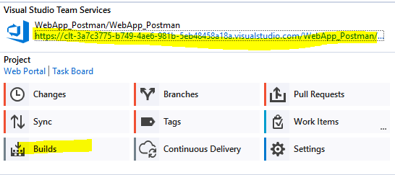

Click on the link to take you to DevOps.

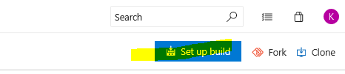

Click on “Set up build”.

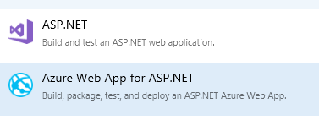

Select Azure Web App

Fill out the input fields and Save & Queue.

DevOps uses a Slack Integration to send a notification to a Slack channel so that we know if the tests passed or failed.

bind TASK RUNNER to build events

Update Node Version in Visual Studio 2017: Tools > Options > Projects and Solutions > Web Package Management > External Web Tools

Put “**C:\Program Files\nodejs**” on top.

task runners like Grunt and Gulp

Command Task Runner : https://marketplace.visualstudio.com/items?itemName=MadsKristensen.CommandTaskRunner

NPM Task Runner: https://marketplace.visualstudio.com/items?itemName=MadsKristensen.NPMTaskRunner

Batch files:

lines can be commented using REM or ::

A watch task keeps an eye on files and directories.